SugarSync registration

1 To register an account, follow the link <https://www.sugarsync.com>.

2. Click on the "Log In".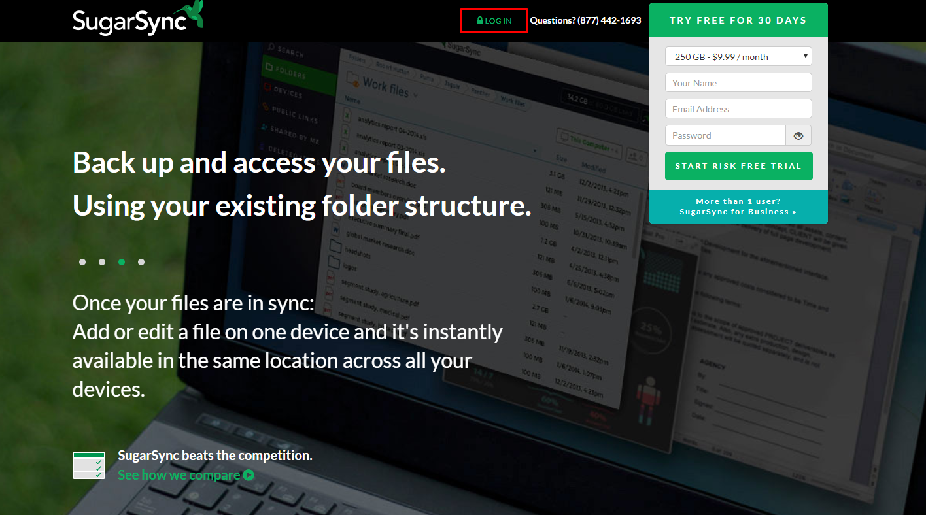

3. Click on the link “Sign up now!”.

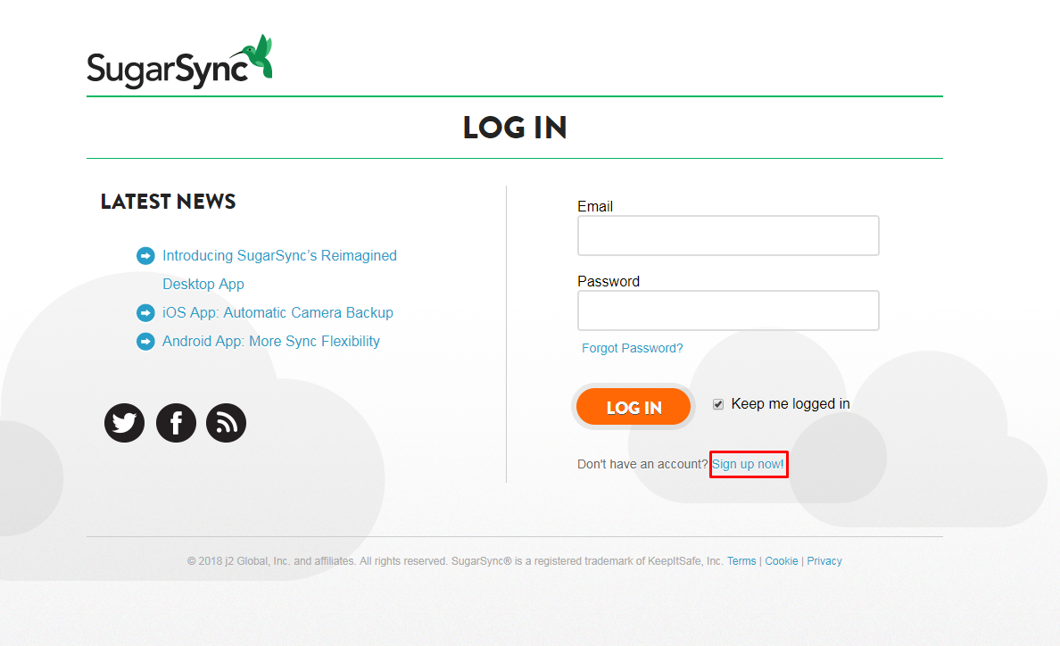

4. Fill in the form and click on the "Limited 5 GB Plan" button.

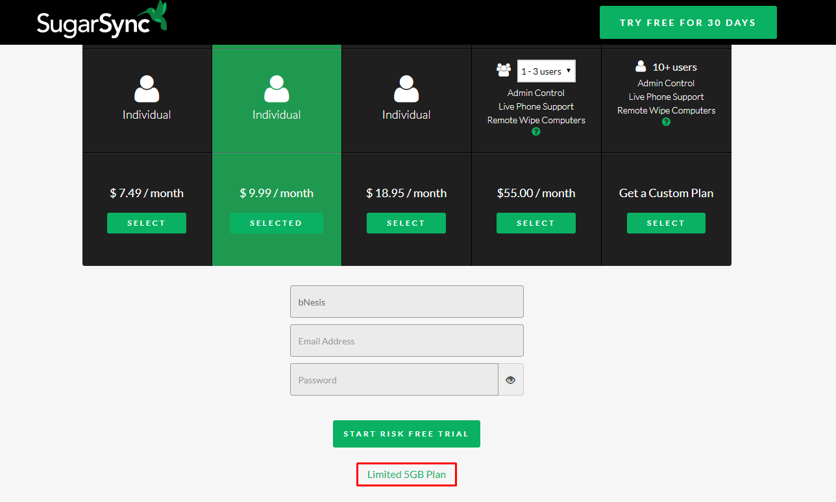

5. Agree to the terms and click on "Download Now".

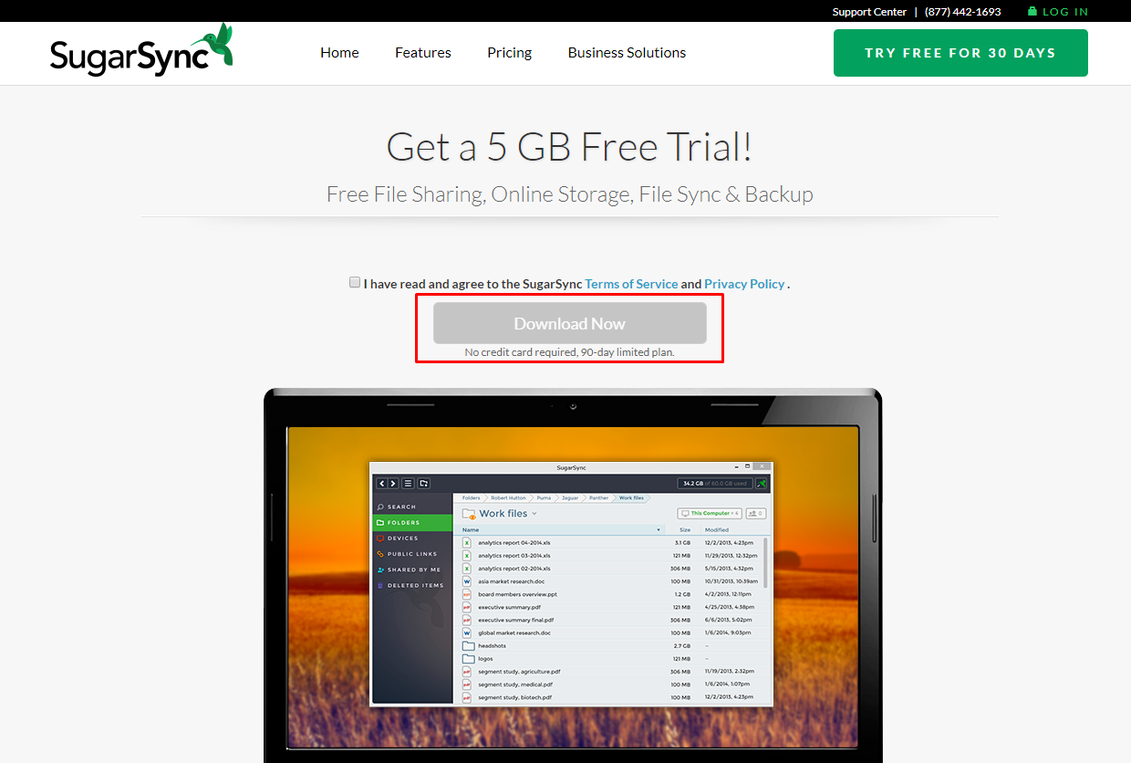

6. You have downloaded the program "SugarSync". Click on the installation file and install this program.

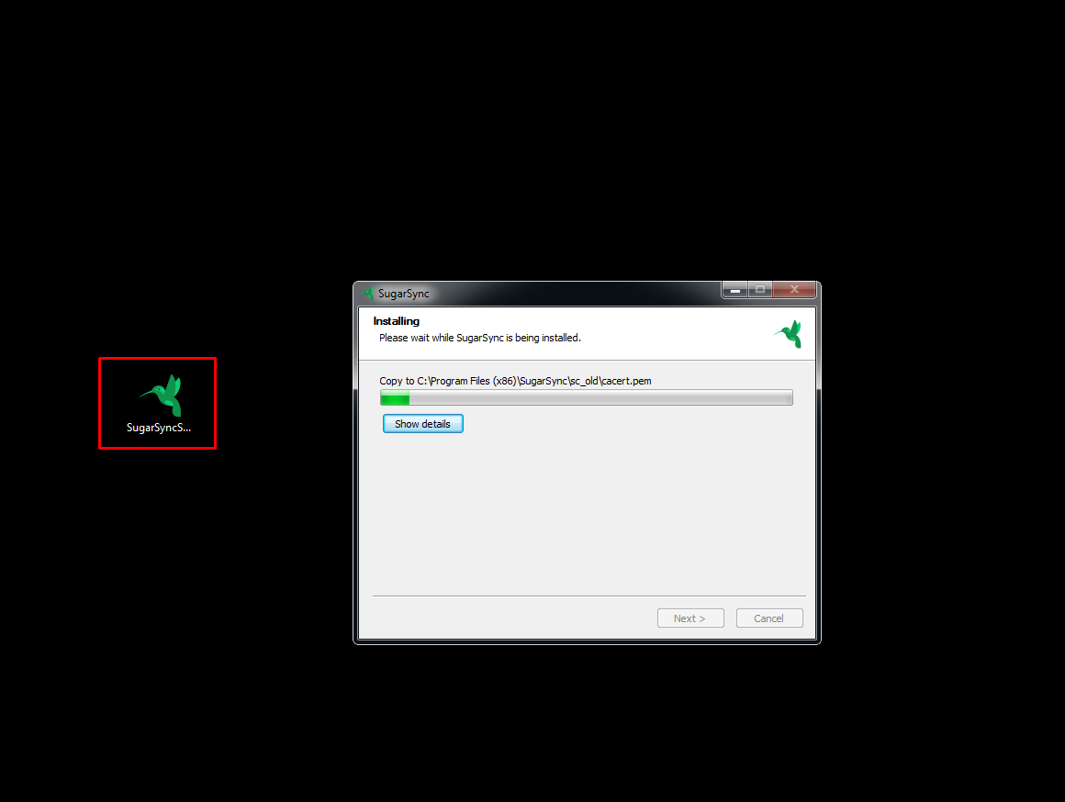

7. Run the installed program and in the open window click on the "Sign Up" button.

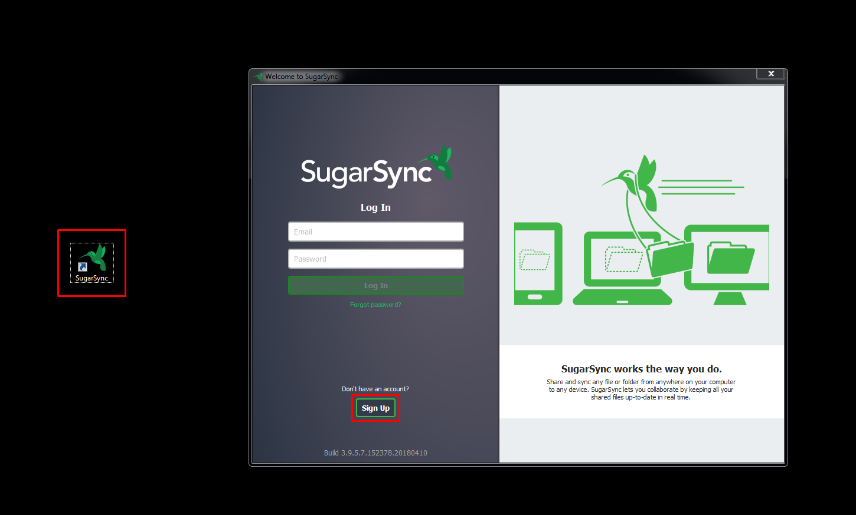

8. Fill out the necessary data and click on the "Sign Up".

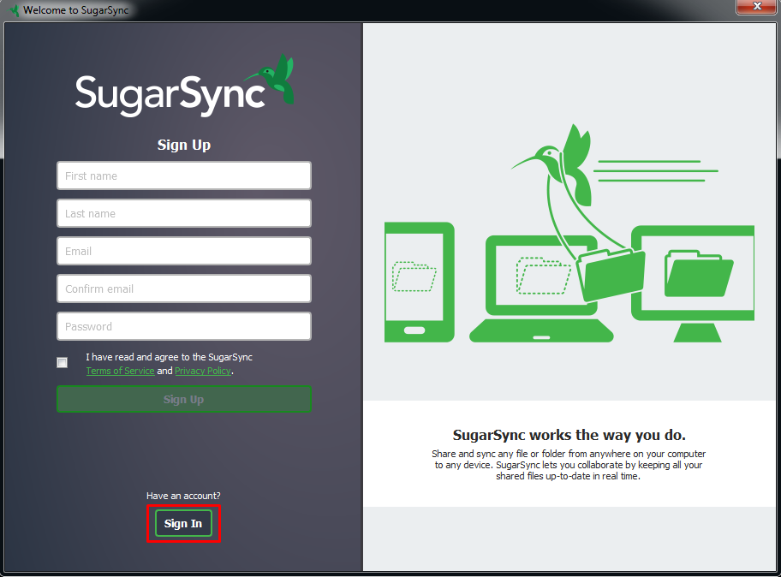

9. Answer the question and click on "OK".

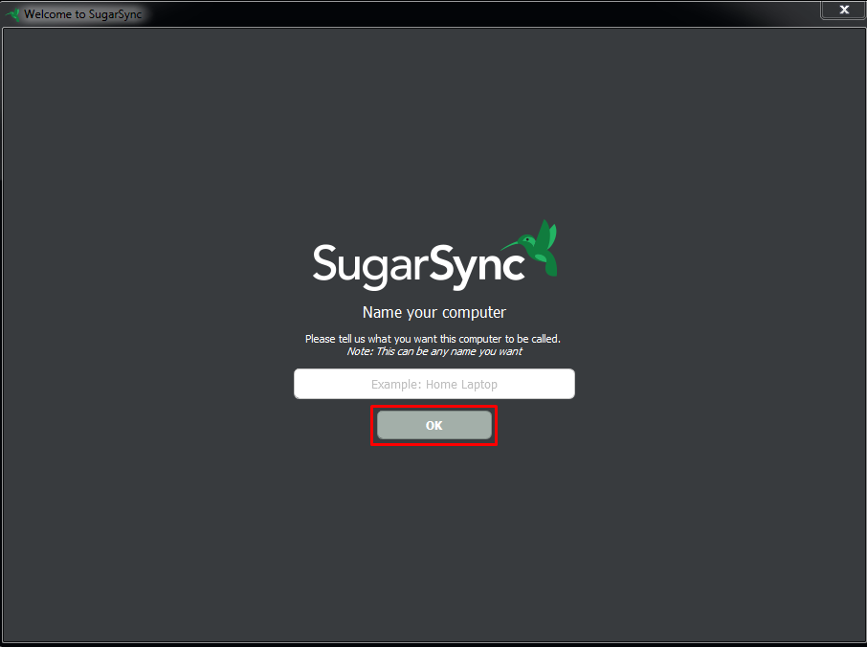

10. You are registered.

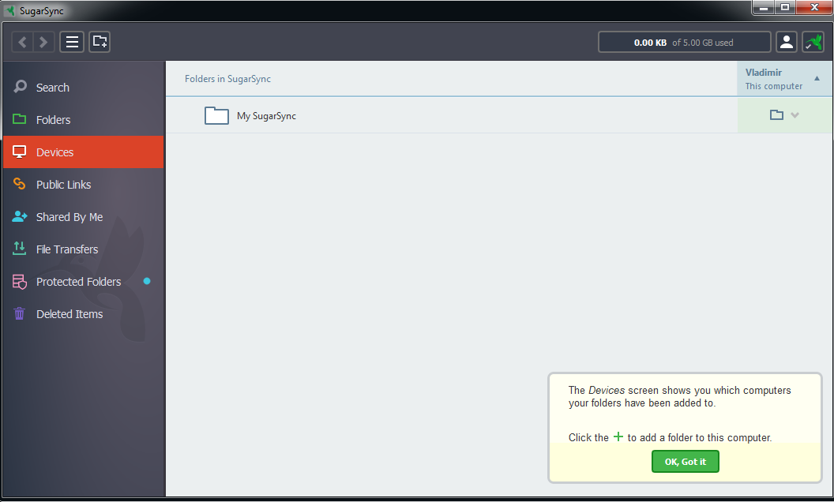

11. Now you need to verify your email. In the mail client, find the email sent to you and click on the "Get Started Now" button.

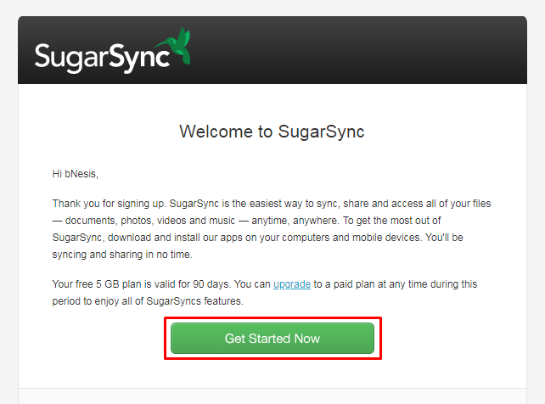

12. After that you will be redirected to the page where you will need to enter your registration data and click on the "Log In" button.

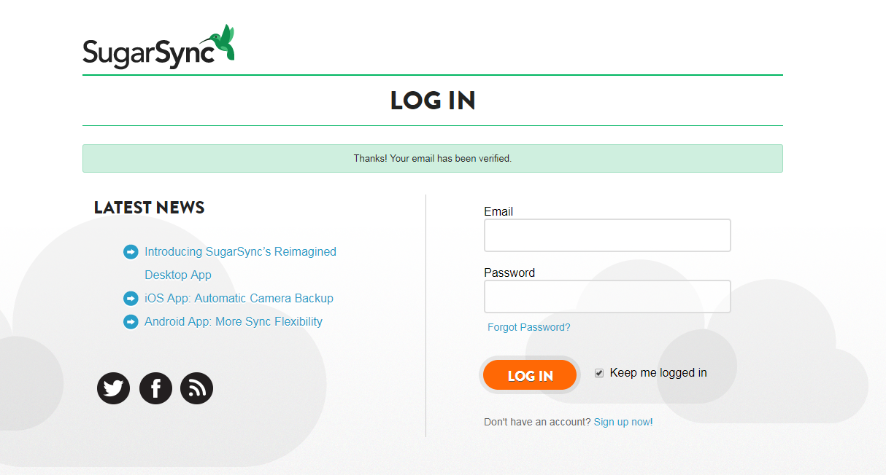

13. Verification and registration of the account was successfully completed.

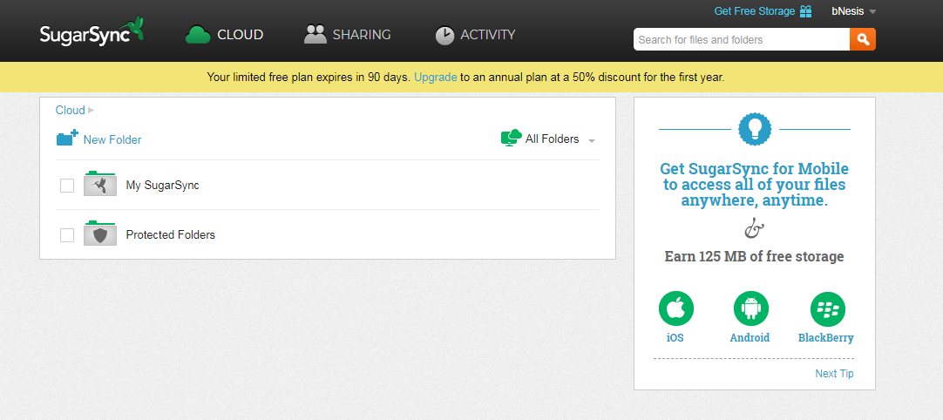

14. To register the application, go to <https://www.sugarsync.com/developer/account>

15. Enter your details for the account and click on "Log in".

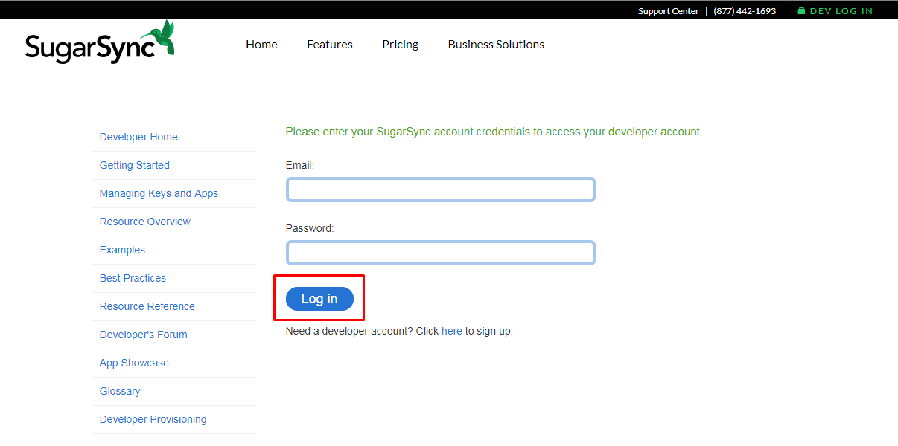

16. Then click on the "Create App" button.

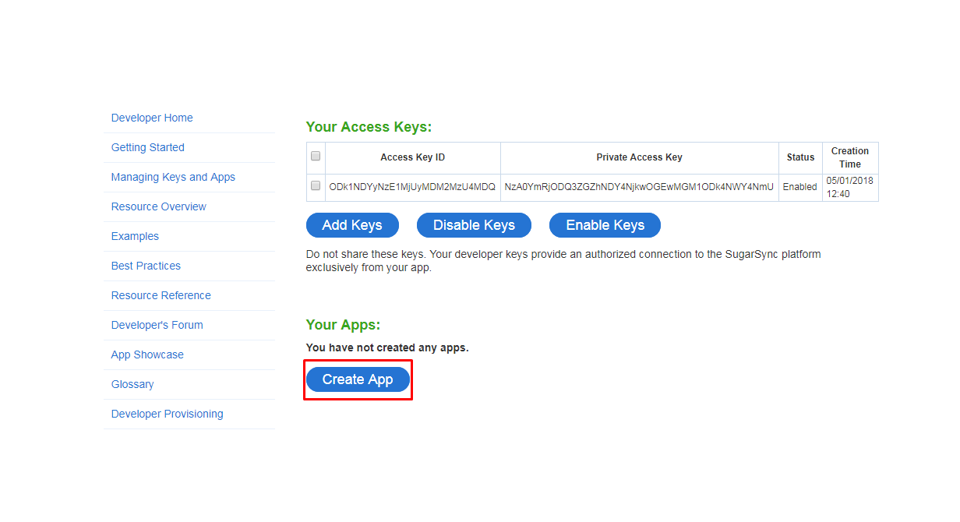

17. Fill in the data in the opened window and click on the "Create App" button.

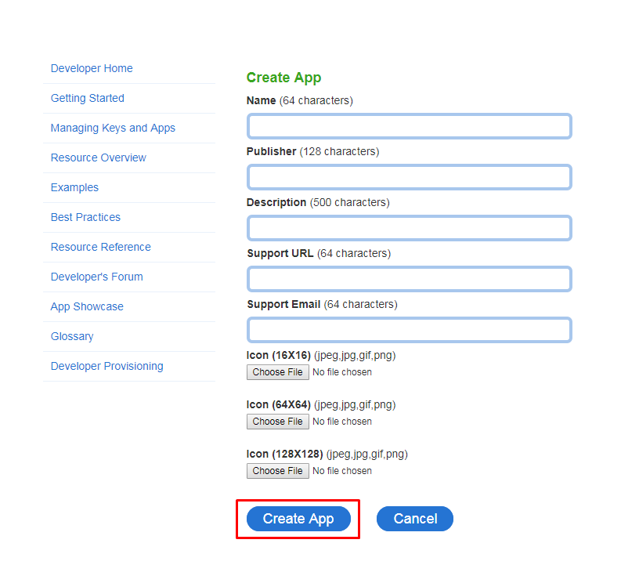

18. In the next window you can get the data necessary for authorization in SugarSync.

